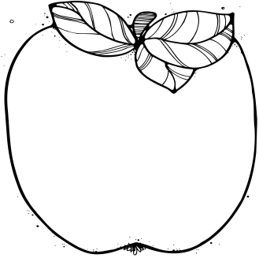

Announcements:  
* Please make sure to send a healthy snack and water bottle each day. * Second grade’s specials time will be changing to 9:30-10:10 for the weeks of 4/9 and 4/16 due to CMAS Testing * To volunteer in our class, please send me an email.

Upcoming Learning:   
**Reading**: We will continue learning about culture around the world through *Magic Tree House* books and nonfiction research.

**Writing:** We will learn how to research George Washington Carver and write a biography about him. Then we will choose our own person to research and write about.

**Math**: We will be starting Module 7 and will be learning all about length, money, and data.

**Advanced Math:** We will be continuing our work with multiplication and division with 3-digit numbers and problem solving.

**Science:** We will be working on our final science unit for the year—Plants! Our essential question is: How are plants important to and affected by humans, animals, and the environment, and what can we do about it?

* **April 5th**

CSC Meeting at 4:30, PTA at 6

* **April 13th at 8:00 am**

Coffee Talk with the Principal

* **April 14th at 6:00 pm**

EdFest

* **April 17th**

Denver Botanic Gardens Field Trip

* **April 20th**

Earth Day Parade at 8:30 am

Health Fair at 3:45

* **April 26th at 4:00 pm**

Author’s Tea

* **April 28th**

Totally Tennyson

April

# Important Dates:

2nd Grade  
 Newsletter