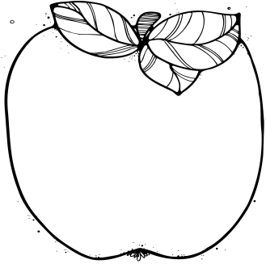M

* **December 7th at 6 pm**

PTA Meeting in the auditorium

* **December 12th-14th**

Scholastic Book Fair in the auditorium

* **December 14th at 5:30 pm**

Literacy Night

* **December 15th (12:45-2:45)**

Second Grade Craft Fair

Please sign-up to volunteer on the classroom Sign-Up Genius page.

* **December 21st**

Dress as your favorite story character to kick off the Read a Thon

* **December 22nd-January 7th**

No School— Make sure to read for the Read a Thon!

Announcements:  
* Please make sure to send a healthy snack and water bottle each day. * To volunteer in our class, please visit <http://www.signupgenius.com/go/4090f48afae2ea7f49-volunteer1>  
* To volunteer at recess, please visit   
<http://www.signupgenius.com/go/4090f48afae2ea7fa7-sign>

Upcoming Learning:   
**Reading**: We will be working on our fifth unit, “Solving Problems Through Technology.” We will focus on annotating a text to identify the main topic and key details.

**Writing:** We will be learning all about how to use adjectives, irregular verbs, and clauses when writing stories based on familiar plots. We will also become experts at writing friendly letters!

**Math**: We will continue composing and decomposing when adding and subtracting numbers up to 200! We will be using many strategies, including base ten blocks, place value charts, algorithms, and friendly, simplifying strategies.

**Social Studies:** We will continue investigating how our community came to be and how we can advocate for change. We will also be working on our final project for the unit.

December

# Important Dates:

2nd Grade  
 Newsletter