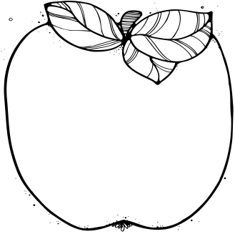

Announcements:  
* Please make sure to send a healthy snack and water bottle each day. * If you would like to bring Valentine’s, please bring enough for the whole class (25 students) * To volunteer in our class, please visit our classroom website or let me know via email.  
Upcoming Learning:   
**Reading**: We will be working on our eighth unit, “Wind and Water Change Earth.” We will be reading non-fiction texts and researching natural landmarks.

**Writing:** We will be conducting research and writing an informational paragraph about an animal of our choice.

**Math**: We will be starting Module 5. We will apply the addition and subtraction strategies we have learned to bigger numbers.

**Advanced Math:** We will be starting Grade 3 Module 2, working with measurement using the metric system and problem solving related to elapsed time.

**Science:** We will be working on our Forces and Motion Unit. Our essential question is: How does applying a force affect the way an object moves and how does that make play more fun?

* **February 2nd**

No School for students

* **February 8th at 6:00 pm**

PTA Meeting in the auditorium

* **February 9th at 6:30 pm**

Rock the Night Away Dance-gym

* **February 14th**

Valentine’s Day

* **February 15th from 6-8 pm**

Student-led conferences and math night

* **February 19th and 20th**

No School for students

* **February 23rd**

Box Tops Collection

* **February 23rd at 2:45 pm**

2nd Grade Performance in the auditorium

February

# Important Dates:

2nd Grade  
 Newsletter