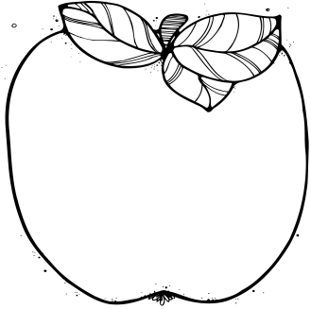

Announcements:  
* Please make sure to send a healthy snack and water bottle each day. * To volunteer in our class, please email me.

Upcoming Learning:   
**Reading**: Starting next week, we will begin our final unit on culture. We will be utilizing *Magic Tree House* books and research to discover culture and traditions around the world.

**Writing:** We will learn how to apply proper dialogue punctuation, combining sentences, and using commas when making lists to writing personal narratives.

**Math**: We will be starting Module 6. This focuses on equal groups, arrays, and even/odd numbers.

**Advanced Math:** We will be starting Grade 3 Module 3. This focuses on multiplication and division with 3-digit numbers and problem solving.

**Science:** We will be starting our final project for our Force and Motion unit. Students will be creating a game that incorporates pushes, pulls, friction, and gravity. Come check them out at 9 am on Tuesday, March 20th.

* **March 8th at 6 pm or March 9th at 8am**

Edison Program Design meeting

* **March 9th at 8:00 am**

ELA-PAC meeting in Mrs. Polenz’s room

* **March 20th at 9:00 am**

Force and Motion Game Showcase

* **March 22nd**

Class Pictures

* **March 22nd**

Field Trip permission form due

* **March 23rd**

Passion Day

* **March 26th – April 2nd**

No School

* **April 3rd – 6th**

Spirit Week

March

# Important Dates:

2nd Grade  
 Newsletter